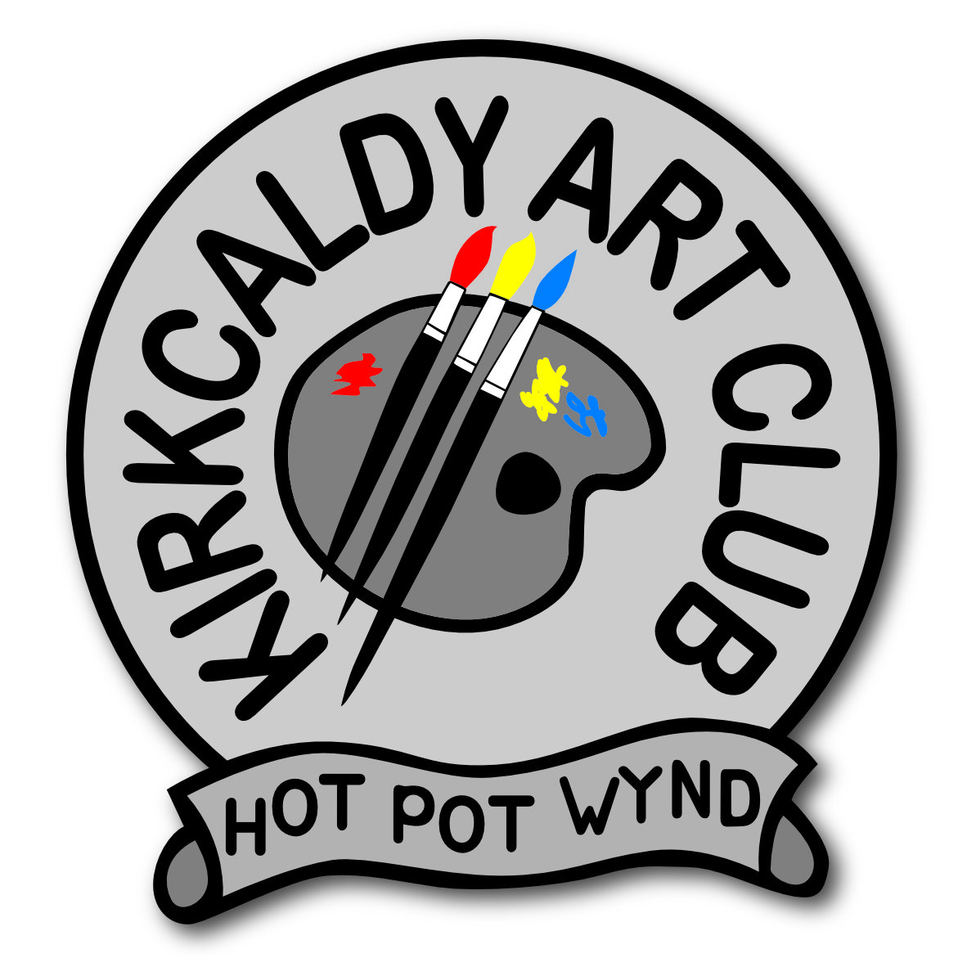**MERCAT shop – Entry form**

Date:

NAME: Tel:

E-mail:

Are you willing to do commissions? YES NO

Are you happy for customers to contact you directly? YES NO

|  |  |  |
| --- | --- | --- |
| **Title of work/Description** | **Price £** | **DATE**  **SOLD** |
|  |  |  |
|  |  |  |
|  |  |  |
|  |  |  |
|  |  |  |
|  |  |  |
|  |  |  |
|  |  |  |
|  |  |  |
|  |  |  |
|  |  |  |
|  |  |  |
|  |  |  |
|  |  |  |
|  |  |  |
|  |  |  |
|  |  |  |
|  |  |  |
|  |  |  |

All items must be for sale. 20% of sales will go to Kirkcaldy Art Club.

Hand a complete list with your work in at the shop in the Mercat, Kirkcaldy. Please keep a copy of this list for yourself. Price each item to 50p or whole £.

**Each item should have a clear, easy to read label with your full name (first & last), title and price. They MUST match your entry form.** If items do not match our terms and conditions they will not be able to go into the shop. **By submitting work you agree to our terms & conditions. (Full T&C’s in members section on the website)**